CINEMA MANAGEMENT SYSTEM
Course: DBI202 – Database Systems
Class: IA2001
Group: 2
Instructor: NhungNTH69

Member | Contribution | Percent
Khưu Hải Nguyên | Code Table + Python | 100
Lê Trường Thịnh | Code Procedure | 100
Nguyễn Minh Tiên | Relation Table | 100
Nguyễn Quốc Anh | Code Procedure + Python | 100
Nguyễn Kim Ngân | ERD Chart + Slide | 100
Võ Ngọc Bảo Trân | ERD Chart + Slide | 100

I. PROBLEM STATEMENT
Design and implement a database system for a cinema to manage movies, screening rooms, seats, showtimes, customers, employees, bookings, food & beverages, and payments. The system supports online booking, seat map management, add-on sales, revenue reporting, and employee administration.
II. SYSTEM FUNCTIONALITIES
The system fulfills the following business requirements:
- Movie Management: Add, delete, view movies. Each movie has an ID, title, genre, duration, rating, director, release date.
- Screening Room Management: Each room has a name and total number of seats.
- Seat Management: Seats belong to a room, have a seat number, type (Standard, VIP, Couple), and base price.
- Showtime Management: Each showtime is linked to a movie, room, date, time, and base ticket price.
- Customer Management: Store customer name and phone number (unique).
- Employee Management: Store employee details (name, position, phone, email, hire date, salary, password, active status).
- Booking: Customer provides name and phone, selects a showtime, chooses seats (max 10 per booking). System checks seat availability, creates a booking record and seat details.
- Food & Beverage Sales: Customers can add popcorn, drinks, or combos to their booking.
- Payment: Create a payment record after booking confirmation.
- Booking Confirmation/Cancellation: Staff can confirm or cancel bookings.
- Reporting: Revenue per month, tickets sold per employee, customer bookings per movie.
- Employee Management: Add new employees, deactivate (fire) employees – only managers have this right.
- Login & Role-based Access: Employees log in with ID and password; managers have additional access to reports and employee management.
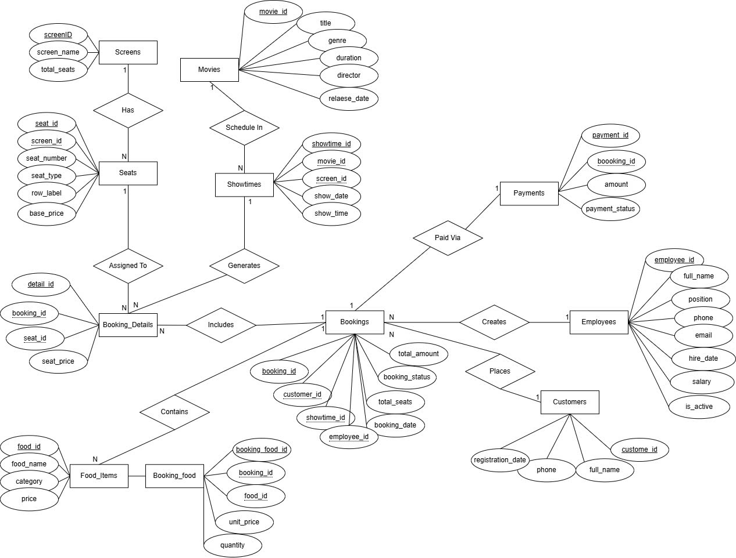

IV. RELATIONAL SCHEMA (FROM ER MODEL)
After conversion, the tables (relations) are defined with primary keys (underlined) and foreign keys (italicized):
Table | Primary Key (PK) | Foreign Key (FK) | Description
Movies | movie_id | — | Stores movie information: title, genre, duration, rating, director, release date.
Screens | screen_id | — | Cinema screen information: screen name, total seats.
Seats | seat_id | screen_id | Seats within a screen: seat number, row, seat type (Standard/VIP/Couple), base price.
Showtimes | showtime_id | movie_id, screen_id | Showtime schedule: which movie plays in which screen, date/time, and base ticket price.
Employees | employee_id | — | Staff records: full name, position, phone, email, hire date, salary, password, active status.
Customers | customer_id | — | Customer records: full name, phone number (unique).
Bookings | booking_id | customer_id, showtime_id, employee_id | Booking orders: customer books via an employee, booking date, order status.
Booking_Details | booking_detail_id | booking_id, seat_id | Booking line items: each row represents one seat in one booking, price at time of booking.
Food_Items | food_id | — | Food & drink menu: item name, price.
Booking_Food | booking_food_id | booking_id, food_id | Food items attached to a booking: quantity and unit price at time of purchase.
Payments | payment_id | booking_id | Payment records: which booking was paid, method (Cash/Card...), timestamp, and amount.

V. DATA DICTIONARY
Table | Column | Data Type | Constraints | Description
Movies | movie_id | INT | PK, IDENTITY | Movie ID
 | title | NVARCHAR(200) | NOT NULL | Title
 | genre | NVARCHAR(50) |  | Genre
 | duration | INT | CHECK (>0 and ≤600) | Duration (minutes)
 | rating | DECIMAL(2,1) | CHECK (0-10) | Rating
 | director | NVARCHAR(100) |  | Director
 | release_date | DATE |  | Release date
Screens | screen_id | INT | PK, IDENTITY | Room ID
 | screen_name | NVARCHAR(50) | NOT NULL | Room name
 | total_seats | INT | CHECK (>0 and ≤500) | Total seats
Seats | seat_id | INT | PK, IDENTITY | Seat ID
 | screen_id | INT | FK → Screens(screen_id) ON DELETE CASCADE | Room ID
 | seat_number | VARCHAR(10) | NOT NULL | Seat number (e.g., A1)
 | row_label | VARCHAR(5) | NOT NULL | Row letter
 | seat_type | NVARCHAR(20) | CHECK (IN('VIP','Standard','Couple')) DEFAULT 'Standard' | Seat type
 | base_price | DECIMAL(10,2) | CHECK (>0 and ≤1000000) | Base price
 |  |  | UNIQUE (screen_id, seat_number, row_label)
Showtimes | showtime_id | INT | PK, IDENTITY | Showtime ID
 | movie_id | INT | FK → Movies(movie_id) ON DELETE CASCADE | Movie ID
 | screen_id | INT | FK → Screens(screen_id) ON DELETE CASCADE | Room ID
 | show_date | DATE | NOT NULL | Date
 | show_time | TIME | NOT NULL | Time
 | base_price | DECIMAL(10,2) | CHECK (>0 and ≤1000000) DEFAULT 100000 | Base ticket price
 |  |  | UNIQUE (screen_id, show_date, show_time)
Customers | customer_id | INT | PK, IDENTITY | Customer ID
 | full_name | NVARCHAR(100) | NOT NULL | Full name
 | phone | VARCHAR(15) | NOT NULL, UNIQUE, CHECK (len=10 and starts with '0') | Phone number
 | registration_date | DATETIME | DEFAULT GETDATE() | Registration date
Employees | employee_id | INT | PK, IDENTITY | Employee ID
 | full_name | NVARCHAR(150) | NOT NULL | Full name
 | position | NVARCHAR(100) |  | Position
 | phone | VARCHAR(15) |  | Phone
 | email | VARCHAR(100) |  | Email
 | hire_date | DATE | DEFAULT GETDATE() | Hire date
 | salary | DECIMAL(12,2) | CHECK (>0) | Salary
 | password_hash | VARCHAR(64) | NOT NULL DEFAULT '123456' | Password (hash)
 | is_active | BIT | DEFAULT 1 | Active status (1=active)
Bookings | booking_id | INT | PK, IDENTITY | Booking ID
 | customer_id | INT | FK → Customers(customer_id) ON DELETE CASCADE | Customer ID
 | showtime_id | INT | FK → Showtimes(showtime_id) ON DELETE CASCADE | Showtime ID
 | employee_id | INT | FK → Employees(employee_id) ON DELETE SET NULL | Employee who processed
 | booking_date | DATETIME | DEFAULT GETDATE() | Booking time
 | total_seats | INT | CHECK (1-10) | Number of seats
 | total_amount | DECIMAL(10,2) | CHECK (>=0) | Total ticket amount
 | booking_status | NVARCHAR(20) | CHECK (IN('Pending','Confirmed','Cancelled')) DEFAULT 'Pending' | Status
Booking_Details | detail_id | INT | PK, IDENTITY | Detail ID
 | booking_id | INT | FK → Bookings(booking_id) ON DELETE CASCADE | Booking ID
 | seat_id | INT | FK → Seats(seat_id) | Seat ID
 | seat_price | DECIMAL(10,2) | CHECK (>0) | Price at booking time
Food_Items | food_id | INT | PK, IDENTITY | Food ID
 | food_name | NVARCHAR(200) | NOT NULL | Name
 | category | NVARCHAR(50) |  | Category
 | price | DECIMAL(10,2) | CHECK (>0) | Price
Booking_Food | booking_food_id | INT | PK, IDENTITY | Food item ID in booking
 | booking_id | INT | FK → Bookings(booking_id) ON DELETE CASCADE | Booking ID
 | food_id | INT | FK → Food_Items(food_id) | Food ID
 | quantity | INT | CHECK (>0) | Quantity
 | unit_price | DECIMAL(10,2) |  | Price at booking time
Payments | payment_id | INT | PK, IDENTITY | Payment ID
 | booking_id | INT | FK → Bookings(booking_id) ON DELETE CASCADE, UNIQUE | Booking ID
 | payment_date | DATETIME | DEFAULT GETDATE() | Payment time
 | amount | DECIMAL(10,2) | CHECK (>=0) | Amount
 | payment_status | NVARCHAR(20) | CHECK (IN('Pending','Paid','Refunded')) DEFAULT 'Pending' | Status

VI. DATA INTEGRITY CONSTRAINTS
- Primary Keys on all tables.
- Foreign Keys as listed in the data dictionary.
- UNIQUE Constraints:
  - Customers.phone
  - Seats (screen_id, seat_number, row_label)
  - Showtimes (screen_id, show_date, show_time)
  - Payments.booking_id
- CHECK Constraints:
  - duration >0 and ≤600
  - rating 0-10
  - total_seats in Screens: 1-500
  - base_price >0 and ≤1000000
  - seat_price >0, quantity >0
  - total_seats in Bookings: 1-10
  - phone length 10 and starts with '0' (partially enforced via stored procedures)
- DEFAULT Constraints:
  - Seats.seat_type = 'Standard'
  - Showtimes.base_price = 100000
  - Customers.registration_date = GETDATE()
  - Employees.hire_date = GETDATE()
  - Employees.password_hash = '123456'
  - Employees.is_active = 1
  - Bookings.booking_date = GETDATE()
  - Bookings.booking_status = 'Pending'
  - Payments.payment_date = GETDATE()
  - Payments.payment_status = 'Pending'
- ON DELETE Actions:
  - CASCADE: Seats, Showtimes, Bookings (customer & showtime), Booking_Details, Booking_Food, Payments
  - SET NULL: Bookings.employee_id
VII. PHYSICAL IMPLEMENTATION
1. Table Creation, Constraints, and Sample Data
Tables are created using script 01_TaoDB_VaBang.sql. Sample data is inserted with 02_InsertData.sql. Indexes are created automatically on primary keys. Additional indexes can be added on frequently searched columns like show_date, movie_id, customer_id, booking_status for performance, but they are not included in the provided scripts.

2. SQL Queries and Answers
Example 1: List available seats for a showtime (using function fn_KiemTraGheTrong)
SELECT * FROM fn_KiemTraGheTrong(1);
Example 2: Total revenue for a specific date (using function fn_TinhTongDoanhThuTheoNgay)
SELECT dbo.fn_TinhTongDoanhThuTheoNgay('2025-03-26');
Example 3: Revenue per month (using stored procedure sp_DoanhThuTheoThang)
EXEC sp_DoanhThuTheoThang 2025, 3, NULL;
Example 4: Tickets sold per employee for year 2025 (using sp_ThongKeVeNhanVien)
EXEC sp_ThongKeVeNhanVien 2025, NULL;
Example 5: Customers who booked per movie in March 2025 (using sp_KhachDatVeTheoPhim)
EXEC sp_KhachDatVeTheoPhim 2025, 3;

3. Triggers for Complex Constraints
The system does not use triggers; all complex constraints are enforced within stored procedures and functions. Examples:
- Duplicate seat check inside sp_TaoDonDatVe.
- Phone number validation inside sp_TaoDonDatVe.
- Overlapping showtime check inside sp_ThemSuatChieu.

4. Stored Procedures and Functions
Function Name | Description
fn_TinhGiaVe | Returns ticket price based on seat type (from base_price in Seats)
fn_KiemTraGheTrong | Returns a table of available seats for a showtime
fn_DemGheDaDat | Counts how many seats are already booked for a showtime
fn_TinhTongDoanhThuTheoNgay | Calculates total revenue from payments on a given date

Procedure Name | Description
sp_ThemPhimMoi | Inserts a new movie; validates required fields
sp_ThemSuatChieu | Inserts a new showtime; checks for conflicts
sp_ThemKhachHang | Inserts a new customer; validates phone number and uniqueness
sp_TaoDonDatVe | Creates a booking with seat list; checks seat availability; creates customer if new
sp_XacNhanDonDatVe | Changes booking status to 'Confirmed'
sp_HuyDonDatVe | Changes booking status to 'Cancelled'
sp_ThanhToan | Creates a payment record for a booking (tickets + food total)
sp_DangNhapNhanVien | Validates employee login; returns employee info
sp_DoiMatKhau | Changes employee password
sp_XoaPhim | Deletes a movie if no bookings exist
sp_SaThaiNhanVien | Deactivates an employee (manager only)
sp_DoanhThuTheoThang | Reports revenue by month/year, optionally per employee
sp_ThongKeVeNhanVien | Reports tickets sold per employee
sp_KhachDatVeTheoPhim | Lists detailed customer bookings per movie

5. SQL Script Files
The SQL scripts must be executed in the following order:
- 01_TaoDB_VaBang.sql – Creates the database CinemaDB and all 11 tables with constraints.
- 02_InsertData.sql – Inserts sample data for movies, rooms, seats, showtimes, food items, and employees.
- 03_Procedures.sql – Creates functions and stored procedures
NOTE : Running file 01, then 03 before 02 ensures that all stored procedures and functions are available for the data insertion process.

VIII. CONCLUSION
The cinema management database system has been fully designed with 11 tables, covering all required business functions: movie, screen, seat, showtime, customer, employee, booking, food, payment, and reporting. The data model ensures integrity through primary keys, foreign keys, CHECK, UNIQUE, and DEFAULT constraints. Stored procedures and functions encapsulate complex business logic (seat availability, booking creation, confirmation, reporting). A Python (Tkinter) application connects to the database via ODBC, providing an intuitive interface for employees to perform booking, add showtimes, generate reports, and manage employees. The system can be extended with online booking for customers, electronic payment integration, and real-time detailed reports.

